1. Core Narrative
Independent title agents are operating in an environment defined by increasing complexity, rising expectations, and constant change.
Transactions are becoming more digital. Fraud risks are intensifying. Operational demands continue to grow.
At the same time, agents are expected to move faster, operate more efficiently, and deliver a consistently elevated customer experience.
Because of you, WFG has built a differentiated model, grounded in experience, strengthened through investment, and designed to support the long-term success of independent title agents.
WFG delivers a complete agent ecosystem that reflects both who we are as a company and how we operate as a partner.
- Agent 3.0 provides the intelligent technology infrastructure, including AI, automation, and integrated systems, that power faster, smarter, and more secure transactions.
- WFG Agency Advantage represents how that same commitment to innovation and leadership is applied operationally through expertise, execution, and hands-on partnership that strengthens your business every day.
Together, this ecosystem is not just a collection of offerings; it is a deliberate, integrated model built from WFG’s real-world experience as an operator, underwriter, and innovator in the title industry.
This is how WFG translates its leadership into measurable value for agents.
This is not just about offering services. It is about how we show up.
It is powered by a culture we call the Greatest of All Teams; a shared commitment across WFG to operate with urgency, accountability, and a relentless focus on helping our agents succeed.
We work alongside you -- through our underwriters, sales representatives, operations teams, and leadership -- to help you solve problems, improve performance, and move your business forward.
- We listen.
- We adapt.
- We respond.
- We deliver as the Greatest of All Teams.
Because of you, we make it happen.

2. Positioning Statement
WFG Agency Advantage is designed to help independent title agents build stronger, more efficient, and more competitive businesses.
It reflects the same philosophy that drives Agent 3.0: Invest in what matters most to title agents, and deliver it in a way that works in the real world.
As part of WFG’s broader title agent ecosystem, it works in conjunction with Agent 3.0 to deliver a comprehensive support structure that combines:
- Innovative technology infrastructure
- Deep underwriting and operational expertise
- Direct, hands-on collaboration with experienced WFG teams
These capabilities are built from WFG’s experience operating at scale across diverse markets and transaction environments.
The result is a model that helps title agents:
- Reduce operational expenses and streamline processes
- Operate with greater precision and consistency
- Navigate complexity with confidence
- Scale their business without adding unnecessary burden
- Capture, convert, and retain more business
All of this is delivered through a culture of shared ownership and performance—WFG’s Greatest of All Teams mindset.

3. The WFG Agent Ecosystem
WFG is the only national underwriter that delivers two fully integrated layers of support:
- Agent 3.0 – Technology Innovation Platform
AI-enabled infrastructure designed to:
- Streamline workflows through automation
- Improve decision-making with data-driven insight
- Strengthen fraud prevention and transaction security
- Reduce friction across the transaction lifecycle
Agent 3.0 reflects WFG’s commitment to building the intelligent infrastructure that powers the future of the title industry.
- WFG Agency Advantage – Operational Enablement
Hands-on operational support designed to:
- Strengthen business performance
- Improve efficiency and scalability
- Reduce operational burden and risk
- Support growth and long-term success

  - Together: A Complete Foundation for Agent Success
Neither technology nor operational support alone is enough. The combination of the two is what creates the true advantage.
WFG Agent 3.0 and Agency Advantage work together to ensure that:
- Your technology evolves with the industry
- Your operations perform at a higher level
- Your business remains competitive in any market

4. What Makes WFG Different
Many underwriters offer similar categories of support. What sets WFG apart is how that support is built, delivered, and continuously improved.
WFG’s operational model is shaped by:
- Decades of underwriting and operational experience across national and local markets
- Direct engagement with agents that informs how solutions are developed and delivered
- Continuous investment in people, processes, and infrastructure aligned to real-world workflows
- A relationship-first approach where trust and collaboration strengthen performance, deepen loyalty, and drive shared success
This translates into:
- Direct access to experienced underwriters who engage, guide, and collaborate
- Sales representatives who assess needs and connect agents to the right expertise
- Operational teams that go beyond expectations to solve real challenges
- A consultative approach focused on solving real operational challenges with speed and clarity
This is not a passive support structure. It is an active, experience-driven operating model designed to help agents perform at a higher level.

This is what it looks like when a high-performance culture is aligned around one goal: your success.

5. The WFG Cornerstones in Action
- Everything We Do Is Because of You
You are at the center of everything we build and deliver.
- We learn from your business
- We listen to your challenges
- We evolve based on your needs
Across both Agent 3.0 and Agency Advantage, every investment is made with one goal: Helping you better serve your customers.

- Take Time and Cost Out of the Real Estate Transaction
Efficiency is not approached as a single initiative, it is engineered across both technology and operations.
- Agent 3.0 reduces friction through automation and intelligent workflows
- Agency Advantage improves processes, production, operational execution, and business development
Together, they create a more streamlined, scalable, and predictable operating environment.
This reflects WFG’s broader commitment: To reduce time, cost, and friction across the transaction lifecycle while strengthening the agent’s ability to perform.
  - Communicate. Collaborate. Co-Exist.
Collaboration at WFG is not an abstract concept, it is an operational standard.
    - Technology enhances visibility and shared insight
- Teams engage directly with title agents in real time
- Solutions are developed through continuous feedback
This creates a model where alignment is not assumed; it is built into how work gets done.
  - Obsess About Service
At WFG, service is not just a function, it’s a defining standard of our GOAT (Greatest of All Teams) culture, powered by a genuine passion for supporting our title agents and a deep commitment to their success. It is the result of intentional structure, clear accountability, and a team that truly cares, working together to consistently deliver at the highest level.
- We respond quickly and proactively
- We engage beyond expectations
- We stay involved until outcomes are achieved
This is what high-performance service looks like when it is operationalized, not just promised.
  - Reimagine the Customer Experience
When agents operate at a higher level, the entire customer experience is elevated, and the relationships at the center of every transaction are strengthened.
Through WFG’s combined ecosystem:
- Transactions become more efficient and transparent
- Communication improves across all stakeholders
- Accuracy and consistency increase
- Trust is strengthened
- Relationships are built and deepened through more consistent, proactive, and connected interactions
The goal is not just operational improvement. It is a fundamentally better transaction experience; one that fosters confidence, strengthens relationships, and drives long-term loyalty.

6. How We Support You
WFG delivers operational support as an integrated extension of your business, designed to strengthen performance, reduce complexity, and create capacity for growth.
This support is built from WFG’s experience operating across the full transaction lifecycle and is continuously refined through direct engagement with title agents.
We work alongside you to:
- Provide underwriting insight and decision support that accelerates transactions while maintaining precision
- Strengthen your production capabilities through scalable solutions and workflow optimization
- Deliver accurate, timely title evidence with a focus on both speed and precision, helping you move transactions forward with confidence and consistency
- Support organizational effectiveness through training, staffing strategy, and consulting
- Help navigate regulatory and risk complexity with compliance and cybersecurity expertise
- Improve cost efficiency through vendor relationships and purchasing advantages
- Enhance market positioning through marketing insight and business development support
We help you build a stronger operational foundation through training, staffing support, workflow optimization, and hands-on consulting, allowing you to scale more effectively and operate with greater consistency.
We also help you navigate increasing complexity with compliance guidance, audit preparation, and cybersecurity advisory support, delivering practical strategies that reduce risk and strengthen your operational resilience.
Through group purchasing programs and vendor relationships, we provide access to cost efficiencies that help improve margins and reduce overhead, bringing the advantages of scale to independent agents.
And to support long-term growth, we offer strategic marketing insight, sales enablement, and business development support, helping you strengthen your market presence and win more business.
Each of these capabilities reflects a single principle: Apply WFG’s experience, scale, and operational expertise in ways that directly improve how agents perform.
This is not fragmented support. It is a coordinated operational model designed to help title agents run stronger, more resilient businesses.

Every part of this support model is delivered through WFG’s Greatest of All Teams approach, ensuring consistency, responsiveness, and execution at every level.

Change to say “When Title Agents operate…”
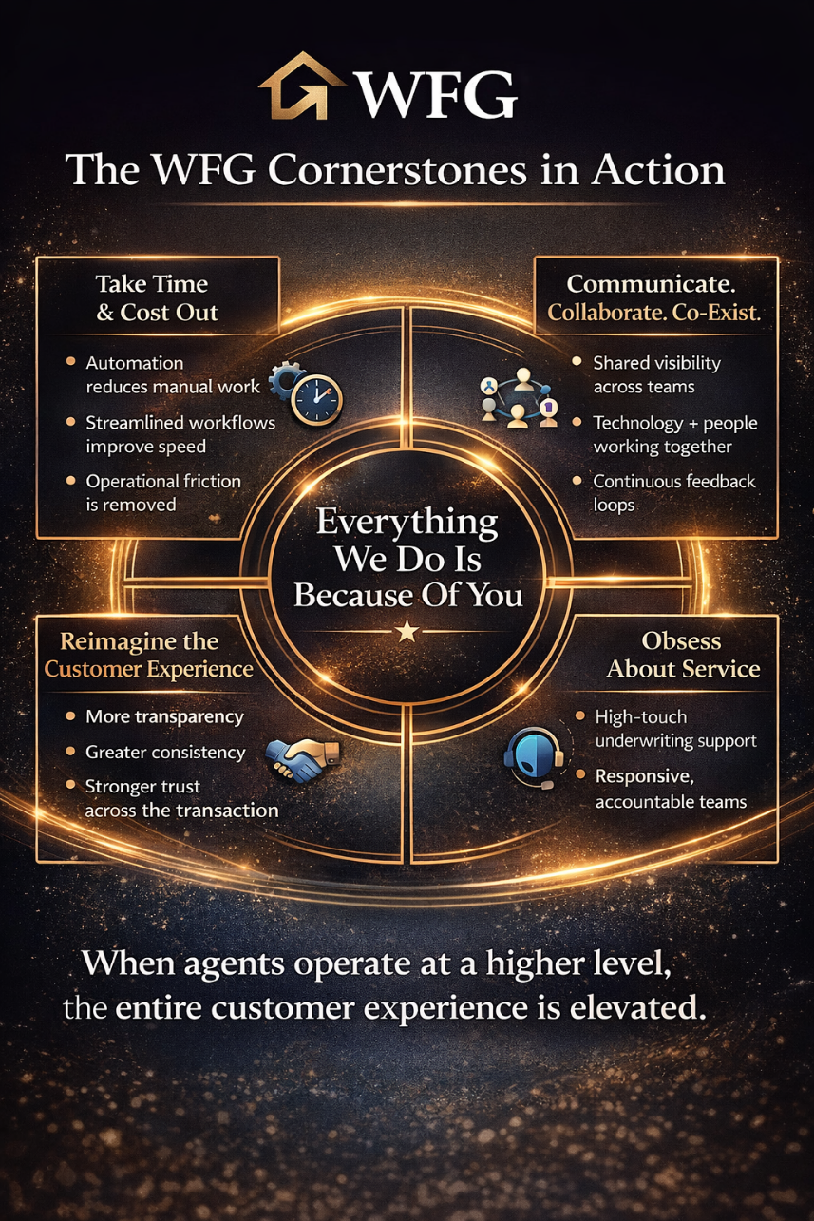

7. The Human Advantage Behind the Ecosystem
Technology enhances performance. People make the difference. At WFG, those people operate as the Greatest of All Teams.
- Underwriters who engage and guide
- Production experts who deliver accurate, timely title and settlement support, bringing speed, precision, and consistency to every transaction
- Sales teams who listen and connect
- Operations professionals who solve problems
- Technology teams who build based on real title agent input
Agent 3.0 provides the infrastructure. Agency Advantage delivers the execution.

Together, they create a model where technology empowers people—and the Greatest of All Teams delivers results.

8. Closing Message
We don’t measure success by scale; we measure it by how well we serve our title agents. At WFG, our focus isn’t on being the biggest, but on being the best at supporting the needs of our title agents and on the strength of the relationships we build with them every day.
Because of you, WFG has built a model that brings together:
  - Intelligent technology infrastructure
  - Operational expertise and execution
  - A culture of accountability, partnership, and care
This is how we turn our experience, investments, and leadership into meaningful outcomes for title agents.
  - A more efficient operation.
  - A more competitive business.
  - A more consistent customer experience.
Delivered through the Greatest of All Teams and aligned around one objective: your success.
Because of you, we make it happen.
# # #

